Nama : Muhammad Ridho Yuneldika

NIM : J3C118023

Kelas : INF 3A Praktikum 1

**TUGAS CRUD**

1. Screenshot alur
2. Menampilkan data

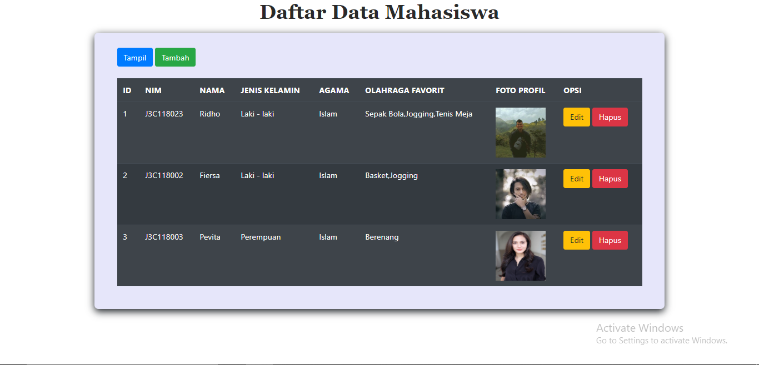

1. Menambah data

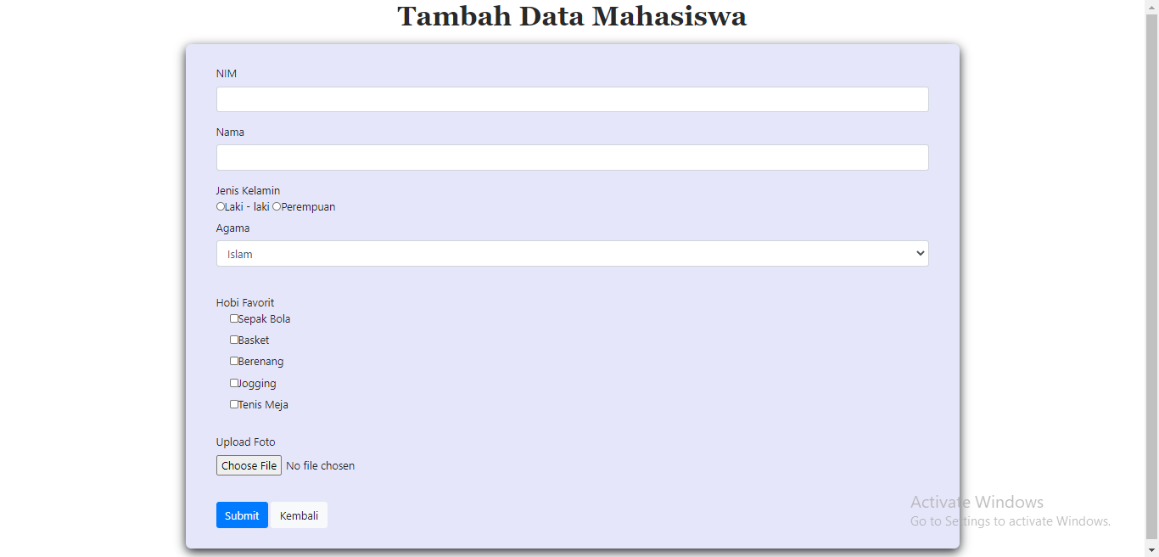

1. Mengedit data

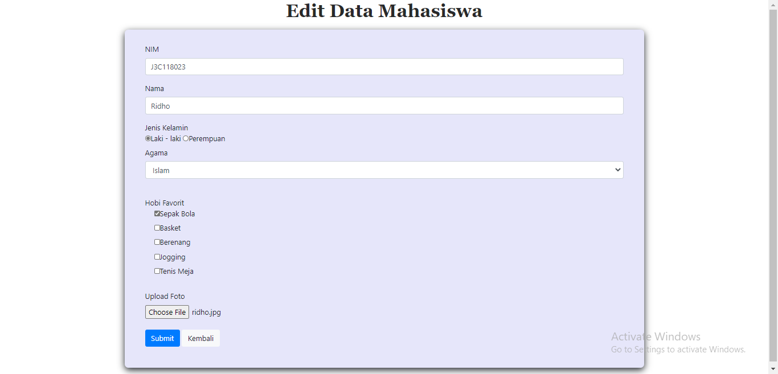

1. Menghapus data

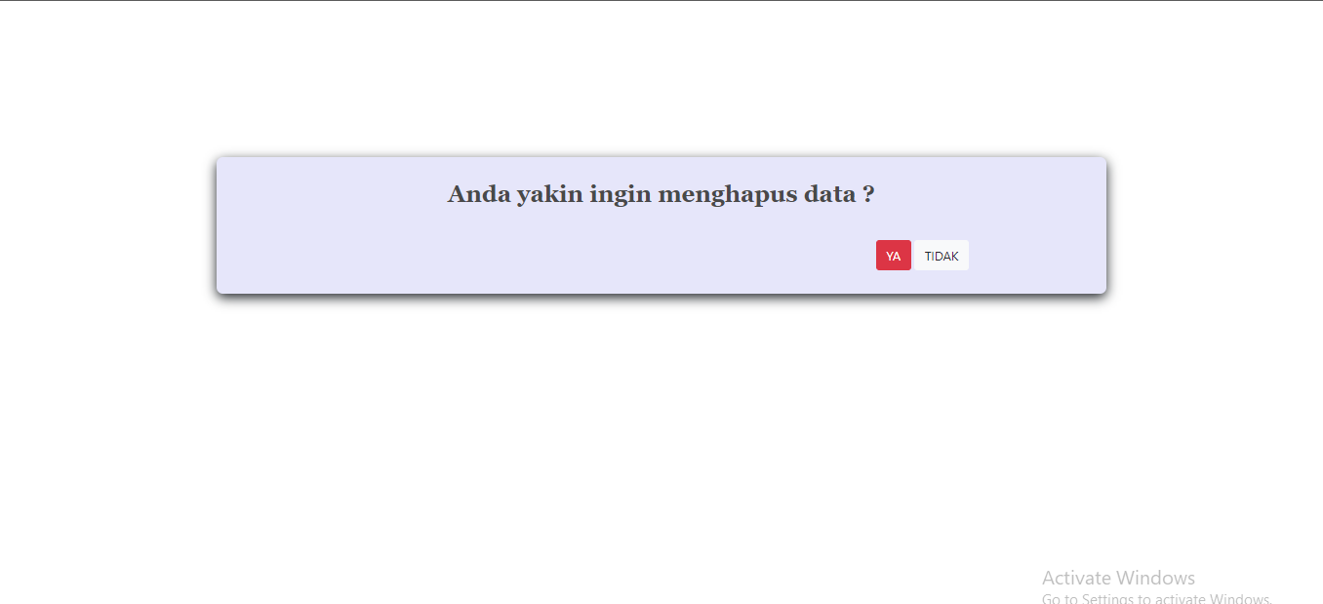

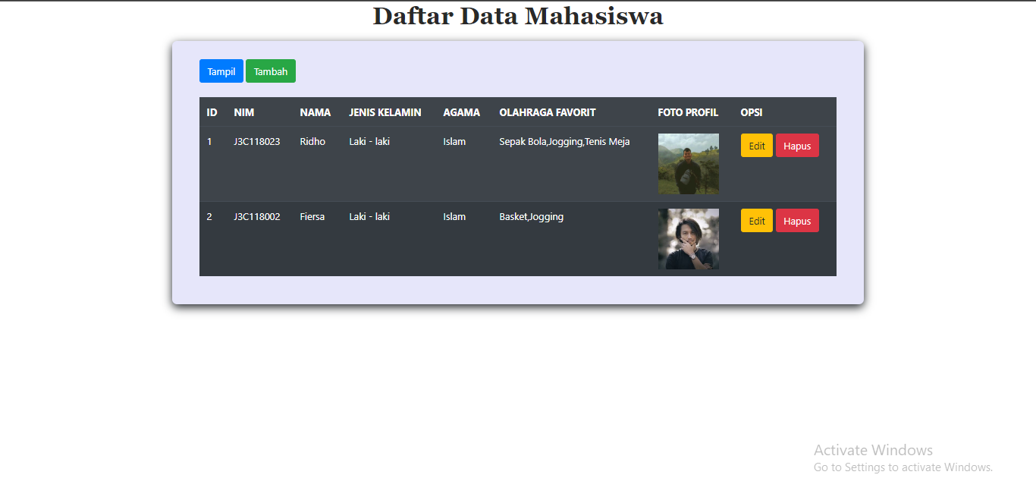

1. Code setiap file

* koneksi.php

<?php

$host = "localhost";

$user = "root";

$psw = "";

$db_name= "pabw";

$kon = mysqli_connect($host,$user,$psw,$db_name);

if (!$kon){

die ('gagal terhubung dengan database:'.mysqli_connect_error());

}

?>

* tampil_data.php

<?php

include "koneksi.php";

$result = mysqli_query($kon,'SELECT * FROM mahasiswa');

?>

<!DOCTYPE html>

<head>

<meta charset="UTF-8">

<meta name="viewport" content="width=device-width, initial-scale=1, shrink-to-fit=no">

<link href="style.css?v=<?php echo time(); ?>" rel="stylesheet" type="text/css" />

<link rel="stylesheet" href="https://stackpath.bootstrapcdn.com/bootstrap/4.5.2/css/bootstrap.min.css" integrity="sha384-JcKb8q3iqJ61gNV9KGb8thSsNjpSL0n8PARn9HuZOnIxN0hoP+VmmDGMN5t9UJ0Z" crossorigin="anonymous">

<title>Database Mahasiswa</title>

</head>

<body>

<div class="hero">

<h1> Daftar Data Mahasiswa</h1>

<div class="container">

<div class="container-dalem">

<a href="tampil_data.php" ><button type="button" class="btn btn-primary">Tampil</button></a>

<a href="insert.php" ><button type="button" class="btn btn-success">Tambah</button></a>

<br>

<br>

<table class="table table-striped table-dark">

<tr>

<th scope="col">ID</th>

<th scope="col">NIM</th>

<th scope="col">NAMA</th>

<th scope="col">JENIS KELAMIN</th>

<th scope="col">AGAMA</th>

<th scope="col">OLAHRAGA FAVORIT</th>

<th scope="col">FOTO PROFIL</th>

<th scope="col">OPSI</th>

</tr>

</thead>

<tbody>

<?php

while ($row=mysqli_fetch_array($result)) // VARIABEL UNTUK CRUD GUNAKAN $row BUKAN $data

{

echo "<tr>";

echo "<td>".$row['id']."</td>";

echo "<td>".$row['nim']."</td>";

echo "<td>".$row['nama']."</td>";

echo "<td>".$row['jk']."</td>";

echo "<td>".$row['agama']."</td>";

echo "<td>".$row['olahraga']."</td>";

echo "<td><img src='images/".$row['foto']."' width='100' height='100'></td>";

echo "<td>"?><a href="edit.php?id=<?php echo $row['id']; ?>" ><button type="button" name="sub" class="btn btn-warning">Edit</button></a>

<a href="delete.php?id=<?php echo $row['id']; ?>"><button type="button" name="sub" class="btn btn-danger">Hapus</button></a>

<?php

}

?>

</tbody>

</table>

</div>

</div>

</div>

<script>

var show = document.getElementById("nav-links");

function showMenu(){

show.style.right = "0";

}

function closeMenu(){

show.style.right = "-200px";

}

</script>

</body>

</html>

* insert.php

<!DOCTYPE html>

<head>

<meta charset="UTF-8">

<meta name="viewport" content="width=device-width, initial-scale=1, shrink-to-fit=no">

<link href="style.css?v=<?php echo time(); ?>" rel="stylesheet" type="text/css" />

<link rel="stylesheet" href="https://stackpath.bootstrapcdn.com/bootstrap/4.5.2/css/bootstrap.min.css" integrity="sha384-JcKb8q3iqJ61gNV9KGb8thSsNjpSL0n8PARn9HuZOnIxN0hoP+VmmDGMN5t9UJ0Z" crossorigin="anonymous">

<title>Tambah Data Mahasiswa</title>

</head>

<body>

<div class="hero">

<h1>Tambah Data Mahasiswa</h1>

<form>

<?php

?>

<div class="container">

<div class="container-dalem">

<div class="form-group">

<label for="exampleFormControlInput1">NIM</label>

<input type="text" class="form-control" id="exampleFormControlInput1" name="nim">

</div>

<div class="form-group">

<label for="exampleFormControlInput1">Nama</label>

<input type="text" class="form-control" id="exampleFormControlInput1" name="nama">

</div>

Jenis Kelamin

<br>

<label><input type="radio" name="jk" value="Laki - laki">Laki - laki</label>

<label><input type="radio" name="jk" value="Perempuan" >Perempuan</label>

<br>

<div class="form-group">

<label for="exampleFormControlSelect1">Agama</label>

<select class="form-control" id="exampleFormControlSelect1" name="agama">

<option value="Islam">Islam</option>

<option value="Kristen">Kristen</option>

<option value="Budha">Budha</option>

<option value="Hindu">Hindu</option>

<option value="Kong Hu Cu">Kong Hu Cu</option>

</select>

</div>

<br>

Hobi Favorit

<div class="form-check">

<label><input type="checkbox" name="olahraga[]" value="Sepak Bola">Sepak Bola</label><br>

<label><input type="checkbox" name="olahraga[]" value="Basket">Basket</label><br>

<label><input type="checkbox" name="olahraga[]" value="Berenang">Berenang</label><br>

<label><input type="checkbox" name="olahraga[]" value="Jogging">Jogging</label><br>

<label><input type="checkbox" name="olahraga[]" value="Tenis Meja">Tenis Meja</label><br>

</div>

<br>

<div class="form-group">

<label for="exampleFormControlFile1">Upload Foto</label>

<input type="file" class="form-control-file" id="exampleFormControlFile1" name="foto">

</div>

<br>

<button type="submit" name="submit" class="btn btn-primary">Submit</button>

<a href="tampil_data.php" ><button type="button" class="btn btn-light">Kembali</button></a>

</div>

</div>

<?php

if (isset($_GET['submit'])){

include "koneksi.php";

$nim = $_GET['nim'];

$nama = $_GET['nama'];

$jk = $_GET['jk'];

$agama = $_GET['agama'];

$olahraga = implode(",",$_GET['olahraga']);

$foto = $_GET['foto'];

mysqli_query($kon," INSERT INTO `mahasiswa` (`nim`, `nama`, `jk`, `agama`, `olahraga`, `foto`) VALUES ('$nim','$nama','$jk','$agama','$olahraga','$foto')");

header("location:tampil_data.php");

//echo '<META HTTP-EQUIV="Refresh" Content="0; URL=tampil_data.php">';

//exit;

};

?>

</div>

<script>

var show = document.getElementById("nav-links");

function showMenu(){

show.style.right = "0";

}

function closeMenu(){

show.style.right = "-200px";

}

</script>

</body>

</form>

</body>

</html>

* edit.php

<!doctype html>

<html lang="en">

<head>

<!-- Required meta tags -->

<meta charset="utf-8">

<meta name="viewport" content="width=device-width, initial-scale=1, shrink-to-fit=no">

<!-- Bootstrap CSS -->

<link href="style.css?v=<?php echo time(); ?>" rel="stylesheet" type="text/css" />

<link rel="stylesheet" href="https://stackpath.bootstrapcdn.com/bootstrap/4.5.2/css/bootstrap.min.css" integrity="sha384-JcKb8q3iqJ61gNV9KGb8thSsNjpSL0n8PARn9HuZOnIxN0hoP+VmmDGMN5t9UJ0Z" crossorigin="anonymous">

<title>Edit Data</title>

</head>

<body>

<div class="hero">

<?php

include "koneksi.php";

$id = $_GET['id'];

$query_mysql = mysqli_query($kon,"SELECT * FROM mahasiswa WHERE id='$id'") or die(mysqli_error(''));

while($row = mysqli_fetch_assoc($query_mysql)){

$dataor = explode(',',$row['olahraga']);

?>

<div class="container-fluid">

<h1>Edit Data Mahasiswa</h1>

<div class="container">

<div class="container-dalem">

<form action="aksi_edit.php" method="POST">

<input type="hidden" name="id" value="<?php echo $row['id'] ?>">

<div class="form-group">

<label for="exampleFormControlInput1">NIM</label>

<input type="text" class="form-control" id="exampleFormControlInput1" name="nim" value="<?php echo $row['nim'] ?>">

</div>

<div class="form-group">

<label for="exampleFormControlInput1">Nama</label>

<input type="text" class="form-control" id="exampleFormControlInput1" name="nama" value="<?php echo $row['nama'] ?>">

</div>

Jenis Kelamin

<br>

<label><input type="radio" name="jk" value="Laki - laki" <?php if($row['jk']=='Laki - laki') echo 'checked'?>>Laki - laki</label>

<label><input type="radio" name="jk" value="Perempuan" <?php if($row['jk']=='Perempuan') echo 'checked'?>>Perempuan</label>

<br>

<div class="form-group">

<label for="exampleFormControlSelect1">Agama</label>

<select class="form-control" id="exampleFormControlSelect1" name="agama">

<option value="Islam" <?php if($row['agama'] == 'Islam') {echo "selected";}?>>Islam</option>

<option value="Kristen" <?php if($row['agama'] == 'Kristen') {echo "selected";}?>>Kristen</option>

<option value="Budha" <?php if($row['agama'] == 'Budha') {echo "selected";}?>>Budha</option>

<option value="Hindu" <?php if($row['agama'] == 'Hindu') {echo "selected";}?>>Hindu</option>

<option value="Kong Hu Cu" <?php if($row['agama'] == 'Kong Hu Cu') {echo "selected";}?>>Kong Hu Cu</option>

</select>

</div>

<br>

Hobi Favorit

<div class="form-check">

<label><input type="checkbox" name="olahraga[]" value="Sepak Bola"

<?php if (in_array("Sepak Bola", $dataor)) echo "checked";?>>Sepak Bola</label><br>

<label><input type="checkbox" name="olahraga[]" value="Basket"

<?php if (in_array("Bola Basket", $dataor)) echo "checked";?> >Basket</label><br>

<label><input type="checkbox" name="olahraga[]" value="Berenang"

<?php if (in_array("Balap Mobil", $dataor)) echo "checked";?>>Berenang</label><br>

<label><input type="checkbox" name="olahraga[]" value="Jogging"

<?php if (in_array("Tenis", $dataor)) echo "checked";?>>Jogging</label><br>

<label><input type="checkbox" name="olahraga[]" value="Tenis Meja"

<?php if (in_array("Esport", $dataor)) echo "checked";?>>Tenis Meja</label><br>

</div>

<br>

<div class="form-group">

<label for="exampleFormControlFile1">Upload Foto</label>

<input type="file" class="form-control-file" id="exampleFormControlFile1" name="foto" value="

<?php if($row['foto']) $row['foto']?>">

<br>

<button type="submit" name="submit" class="btn btn-primary">Submit</button>

<a href="tampil_data.php" ><button type="button" class="btn btn-light">Kembali</button></a>

</div>

</form>

</div>

</div>

<?php } ?>

</div>

<script>

var show = document.getElementById("nav-links");

function showMenu(){

show.style.right = "0";

}

function closeMenu(){

show.style.right = "-200px";

}

</script>

<!-- Optional JavaScript -->

<!-- jQuery first, then Popper.js, then Bootstrap JS -->

<script src="https://code.jquery.com/jquery-3.5.1.slim.min.js" integrity="sha384-DfXdz2htPH0lsSSs5nCTpuj/zy4C+OGpamoFVy38MVBnE+IbbVYUew+OrCXaRkfj" crossorigin="anonymous"></script>

<script src="https://cdn.jsdelivr.net/npm/popper.js@1.16.1/dist/umd/popper.min.js" integrity="sha384-9/reFTGAW83EW2RDu2S0VKaIzap3H66lZH81PoYlFhbGU+6BZp6G7niu735Sk7lN" crossorigin="anonymous"></script>

<script src="https://stackpath.bootstrapcdn.com/bootstrap/4.5.2/js/bootstrap.min.js" integrity="sha384-B4gt1jrGC7Jh4AgTPSdUtOBvfO8shuf57BaghqFfPlYxofvL8/KUEfYiJOMMV+rV" crossorigin="anonymous"></script>

</body>

</html>

* aksi_edit.php

<?php

include 'koneksi.php';

$id = $_POST['id'];

$nim = $_POST['nim'];

$nama = $_POST['nama'];

$jk = $_POST['jk'];

$agama = $_POST['agama'];

$olahraga = implode(",",$_POST['olahraga']);

$foto = $_POST['foto'];

mysqli_query($kon,"UPDATE mahasiswa SET nim='$nim', nama='$nama', jk='$jk', agama='$agama', olahraga='$olahraga', foto='$foto' WHERE id='$id'") or die(mysqli_error(''));

header("location:tampil_data.php");

?>

* delete.php

<!doctype html>

<html lang="en">

<head>

<!-- Required meta tags -->

<meta charset="utf-8">

<meta name="viewport" content="width=device-width, initial-scale=1, shrink-to-fit=no">

<!-- Bootstrap CSS -->

<link href="style.css?v=<?php echo time(); ?>" rel="stylesheet" type="text/css" />

<link rel="stylesheet" href="https://stackpath.bootstrapcdn.com/bootstrap/4.5.2/css/bootstrap.min.css" integrity="sha384-JcKb8q3iqJ61gNV9KGb8thSsNjpSL0n8PARn9HuZOnIxN0hoP+VmmDGMN5t9UJ0Z" crossorigin="anonymous">

<title>Hapus data</title>

</head>

<body>

<div class="hero">

<form style="margin-top:200px">

<?php

include "koneksi.php";

$r = mysqli_query($kon,"SELECT * FROM mahasiswa WHERE id=".$_GET["id"]);

$brs = mysqli_fetch_assoc($r);

?>

<div class="container">

<div class="container-dalem">

<h1 style="text-align:center">Anda yakin ingin menghapus data ?</h1>

<br>

<input type="hidden" name="idDelete" value="<?php echo $_GET["id"]; ?>">

<input style="margin-left: 800px;" type="submit" name="jawab" value="YA" class="btn btn-danger"></input>

<input style="text-align:center;" type="submit" name="jawab" value="TIDAK" class="btn btn-light"></input >

</form>

</div>

</div>

<?php

if(isset($_GET['jawab'])){

if($_GET['jawab']=="YA"){

$r = mysqli_query($kon,"DELETE FROM `mahasiswa` WHERE `id` = ".$_GET['idDelete']);

header("location:tampil_data.php");}

else{

header("location:tampil_data.php");

}

}

?>

</div>

<script>

var show = document.getElementById("nav-links");

function showMenu(){

show.style.right = "0";

}

function closeMenu(){

show.style.right = "-200px";

}

</script>

<!-- Optional JavaScript -->

<!-- jQuery first, then Popper.js, then Bootstrap JS -->

<script src="https://code.jquery.com/jquery-3.5.1.slim.min.js" integrity="sha384-DfXdz2htPH0lsSSs5nCTpuj/zy4C+OGpamoFVy38MVBnE+IbbVYUew+OrCXaRkfj" crossorigin="anonymous"></script>

<script src="https://cdn.jsdelivr.net/npm/popper.js@1.16.1/dist/umd/popper.min.js" integrity="sha384-9/reFTGAW83EW2RDu2S0VKaIzap3H66lZH81PoYlFhbGU+6BZp6G7niu735Sk7lN" crossorigin="anonymous"></script>

<script src="https://stackpath.bootstrapcdn.com/bootstrap/4.5.2/js/bootstrap.min.js" integrity="sha384-B4gt1jrGC7Jh4AgTPSdUtOBvfO8shuf57BaghqFfPlYxofvL8/KUEfYiJOMMV+rV" crossorigin="anonymous"></script>

</body>

</html>

* style.css

*{

margin: 0;

padding: 0;

font-family: -apple-system, BlinkMacSystemFont, 'Segoe UI', Roboto, Oxygen, Ubuntu, Cantarell, 'Open Sans', 'Helvetica Neue', sans-serif;

}

.hero h1{

text-align: center;

color: rgb(41, 41, 41);

padding-bottom: 10px;

font-weight: bold;

font-family: Georgia, 'Times New Roman', Times, serif;

}

.vertical-bar{

height: 100%;

background: black;

top: 0;

left: 0;

position: absolute;

}

.nav-bar .fa{

display: none;

}

.container{

margin: 20px auto;

margin-top: 0px;

background-color: rgb(230,230,250);

height: auto;

width: 65% ;

border-radius: 8px;

box-shadow: 0px 5px 15px 0px;

position: relative;

}

.flex-parent{

display: flex;

}

.jc-center{

justify-content: center;

}

button.margin-right{

margin-right: 20px;

}

button.margin-bottom{

margin-bottom: 20px;

}

.container h1{

font-weight: bold;

color:rgb(73, 73, 73);

text-align: center;

font-size: 30px;

}

.jarakBwh{

margin-bottom: 20px;

}

.container-dalem{

padding: 30px;

align-items: center;

}

table, th, td {

border-collapse: collapse;

margin: 0 auto;

}

.hover:hover{

background-color:#f8f0ffc7;

}

th{

color: rgb(255, 255, 255);

font-weight: bold;

}

.paddingKcl {

padding: 7px;

text-align: left;

}

.long{

width: 90%;

}

.short{

width: 1%;

}

.text{

text-align: center;

}

.vertical-center{

margin: 0 auto;

}

.column {

float: left;

width: 20%;

padding-bottom:10px;

height: auto;

}

* mahasiswa.sql

-- phpMyAdmin SQL Dump

-- version 5.0.2

-- https://www.phpmyadmin.net/

--

-- Host: 127.0.0.1

-- Generation Time: Sep 26, 2020 at 07:16 AM

-- Server version: 10.4.11-MariaDB

-- PHP Version: 7.4.4

SET SQL_MODE = "NO_AUTO_VALUE_ON_ZERO";

START TRANSACTION;

SET time_zone = "+00:00";

/*!40101 SET @OLD_CHARACTER_SET_CLIENT=@@CHARACTER_SET_CLIENT */;

/*!40101 SET @OLD_CHARACTER_SET_RESULTS=@@CHARACTER_SET_RESULTS */;

/*!40101 SET @OLD_COLLATION_CONNECTION=@@COLLATION_CONNECTION */;

/*!40101 SET NAMES utf8mb4 */;

--

-- Database: `pabw`

--

-- --------------------------------------------------------

--

-- Table structure for table `mahasiswa`

--

CREATE TABLE `mahasiswa` (

`id` int(2) NOT NULL,

`nim` varchar(9) NOT NULL,

`nama` varchar(10) NOT NULL,

`jk` varchar(15) NOT NULL,

`agama` varchar(10) NOT NULL,

`olahraga` varchar(50) NOT NULL,

`foto` varchar(50) NOT NULL

) ENGINE=InnoDB DEFAULT CHARSET=utf8mb4;

--

-- Dumping data for table `mahasiswa`

--

INSERT INTO `mahasiswa` (`id`, `nim`, `nama`, `jk`, `agama`, `olahraga`, `foto`) VALUES

(1, 'J3C118023', 'Ridho', 'Laki - laki', 'Islam', 'Sepak Bola,Jogging,Tenis Meja', 'ridho.jpg'),

(2, 'J3C118002', 'Fiersa', 'Laki - laki', 'Islam', 'Basket,Jogging', 'fiersa.jpg'),

(3, 'J3C118003', 'Pevita', 'Perempuan', 'Islam', 'Berenang', 'pevita.jpg');

--

-- Indexes for dumped tables

--

--

-- Indexes for table `mahasiswa`

--

ALTER TABLE `mahasiswa`

ADD PRIMARY KEY (`id`);

--

-- AUTO_INCREMENT for dumped tables

--

--

-- AUTO_INCREMENT for table `mahasiswa`

--

ALTER TABLE `mahasiswa`

MODIFY `id` int(2) NOT NULL AUTO_INCREMENT, AUTO_INCREMENT=4;

COMMIT;

/*!40101 SET CHARACTER_SET_CLIENT=@OLD_CHARACTER_SET_CLIENT */;

/*!40101 SET CHARACTER_SET_RESULTS=@OLD_CHARACTER_SET_RESULTS */;

/*!40101 SET COLLATION_CONNECTION=@OLD_COLLATION_CONNECTION */;